Peanut Butter Kiss Holiday Cookies

Holiday Peanut Butter Kiss Cookies

**Yield:**30 - 40 cookies, depending on the size of cookie

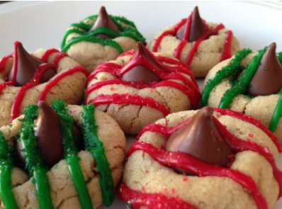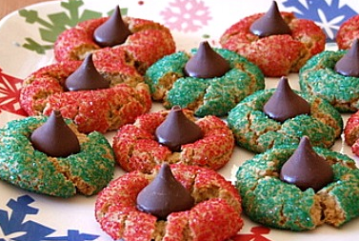

INGREDIENTS:

* 1/2 C. Sugar
* 1/2 C. Brown Sugar
* 1/2 C. Peanut Butter
* 1/2 C. Shortening
* 2 TBS. Milk
* 1 tsp. Vanilla
* 1 Egg
* 1 3/4 C. [Pamela’s All-Purpose Flour Artisan Blend](http://www.pamelasproducts.com/products/baking-mixes/artisan-flour-blend/)
* 1 tsp. Baking Soda
* 1 Pkg. of Hershey's Kisses
* You will need extra sugar on the side to roll the cookies in.

DIRECTIONS:

Preheat Oven to 375°.

Mix all ingredients together with your favorite mixing spoon except for the flour. Add half of the flour and mix. Add the rest of the flour and mix. Roll cookies into balls. Roll balls in sugar. Place on cookie sheet and bake for 8 minutes. In the meantime, start unwrapping the Hershey's Kisses. As soon as you take the cookies out of the oven, place Hershey's Kisses in middle of cookies.

Allow cookies to cool before decorating with frosting and sprinkles.

### **TIPS:**

*You can easily make this a Christmas cookie by rolling the PB balls in red and green sugar.